*We Are Here For You*

Phone: 815-385-1813

**We Guarantee Fast and Reliable Computer Repair with No hidden charges, No Repair No Charge.**

**ProFix Computer Repair**













3401 Pearl St.

McHenry Il. 60050

Phone: 815-385-1813

Mobile: 815-403-7180

help@profixcomputers.net

#### C:\Users\ProFix\Desktop\sign.jpg

# *We Can Help !*

# We offer Free diagnostics in our shop, for [Virus](http://profixcomputers.net/Spy.html" \o "remove moneypac fbi virus)es, pop-ups, slow start-ups, [internet](http://profixcomputers.net/Spy.html), Blue Screen and other hardware problems, We do it all ... We offer Free estimates and Flat Rates. You will know what your costs are before any work is billed. No one likes surprises at the repair shop. We back up all our work for 30 days.

"We have been in the Technology business since 1996, so you can rest assured that we are more than capable of addressing your needs. Our goal is a long standing mutually beneficial relationship. Most of our clients are from satisfied referrals"

Frank McClatchey

ProFix is a Full Service Computer Repair and Tech support company. We provide computer support for small businesses, professionals, and residential or home clients. We are here for you... We have trained professionals available at a fraction of the cost typically associated with this level of computer service provided by other companies. If you want your PC, Laptop, Desktop Fixed right, choose ProFix

Visit us at: **www.profixcomputers.net**

**Does your Computer have problems?**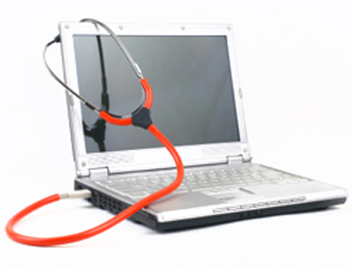

**3401 Pearl St. McHenry Il, 60050**

**815-385-1813**



#### ProFix Computer Repair Serving the McHenry and Johnsburg Area

[**BEWARE OF SCAMS!**](https://www.youtube.com/watch?v=kKFSu_hoxuw)

**Many computer problems can be handled on-site but when possible most repairs should be done in a shop as it generally results in a savings of at least 40% along with a much greater degree of reliability, Like Virus removal, Motherboard repairs, DC jack replacement and speed up your PC. Call us to discuss your options, We will save you money**.